Create Your Own Agentic Squad to Build Power Apps

Prerequisites
- Need to have admin rights on your environment (to install required modules)
- Github Copilot License
- Node.js
- Pac CLI
- Git (optional)
- PowerShell 5
- PowerShell 7 (to install Playwright prerequisites)
- VSCode
- GitHub Copilot
- .NET 9

Modules
- Lab 0 – setting up
- Lab 1 – Schema
- Lab 2 – Model Driven Apps Forms
- Lab 3 – Deployment
- Lab 4 – Cloud Flows
- Lab 5 – Front-end JavaScript
- Lab 6 – Back-end Plugins
- Lab 7 – Security Review
- Lab 8 – Playwright MCP
- Lab 9 – Regression Testing

Use case
We are Zava, a public sector workplace health and safety regulator.
Our role is to help ensure that people return home from work healthy and safe, and to hold organisations accountable when they fail to manage workplace risk.
We receive notifications via from the public through manual channels such as emails, letters, or phone call where organizations notify us on an incident that took place at work. We have a responsibility to respond go incidents, especially urgent one where a severe injury or fatality occurred.
Once we receive an application, we triage them and dispatch a team to investigate.
Our CIO is concerned that we are too slow in building new regimes and expose them to the public. They also have concerns regarding the quality of our deliverables.
Our COO noticed that we spend too much time figuring out what is happening before we respond to an incident and our triage processes are slow as well. We need to automate the process.

Lab 0 – Setting up your environment

Repo
Clone the repository PPCC26 repository
https://github.com/ramimounla/AgenticLabPPCC26.git
If you don’t have git tools installed, simply download the zip file from
https://github.com/ramimounla/AgenticLabPPCC26
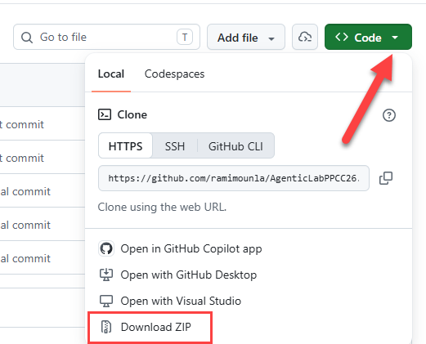

Activate your account
Login to https://make.powerapps.com using your provided credentials (you might have to reset your password).
Switch from the default environment to your environment (there should only be one) and copy your environment GUID.
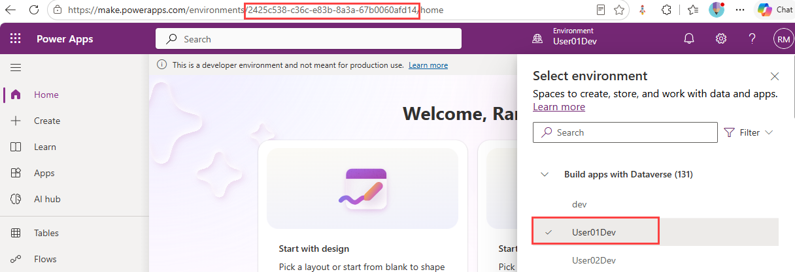
Mark the PPCC26 solution are your preferred solution
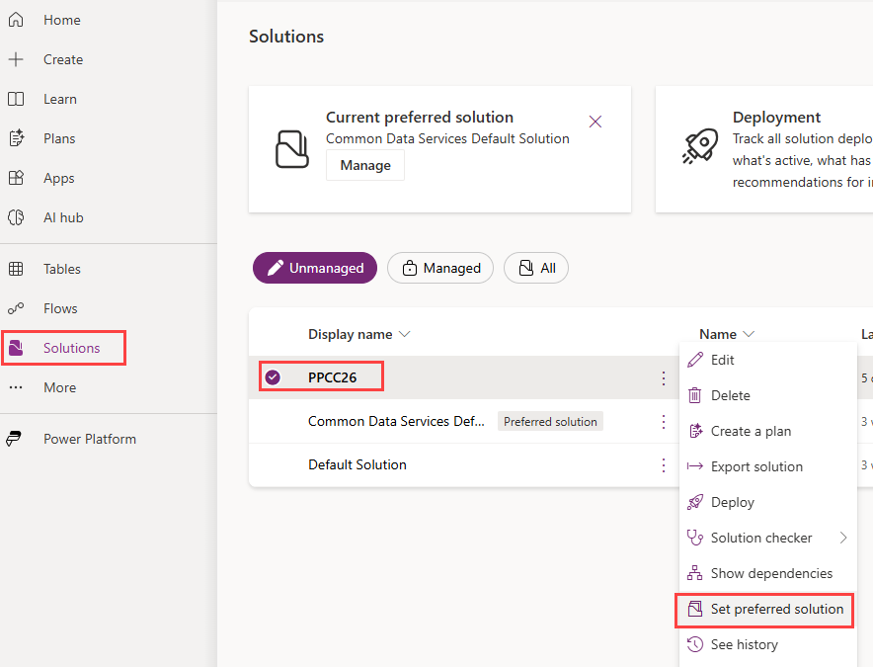

PAC CLI
You can download and install the PAC CLI from
https://learn.microsoft.com/en-us/power-platform/developer/howto/install-cli-msi#install
Once installed login using the following command
pac auth create --environment <EnvironmentGUID>
You can get the GUID from the previous step.

Github Copilot License
If you don’t have a Github license with enough credits, use the email address for the register a new account with Github and you will receive a free license.

PowerShell 7 – check (PoweShell 7 is not required)
Check if you have PowerShell 7 installed by open a PowerShell prompt and typing
pwsh
If the response is something like PowerShell 7.6.9
Then you have PowerShell 7 installed.
$PSVersionTable.PSVersion

PowerShell 5
Open PoweShell ISE in admin mode and run the following commands:
Install-Module -Name Microsoft.PowerApps.Administration.PowerShell
Install-Module -Name Microsoft.Xrm.Data.PowerShell -Scope CurrentUser -Force
Set-ExecutionPolicy -ExecutionPolicy RemoteSigned -Scope CurrentUser -Force

Plugins and Skills
Setting up Power Platform plugin in Copilot CLI
https://github.com/microsoft/power-platform-skills
Start Copilot CLI and run the following commands
/plugin marketplace add microsoft/power-platform-skills
/plugin install power-automate@power-platform-skills
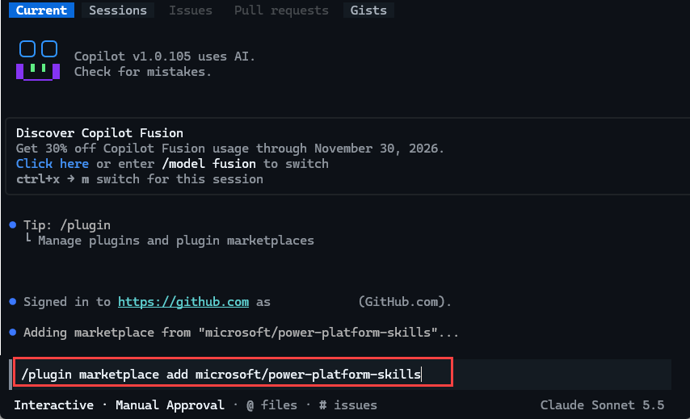

You also have to ensure you are connected the your environment using az login
az login --tenant 94edb735-a837-4d0d-80c3-4f9d2b11120c --allow-no-subscriptions

Playwright MCP Server
Install the prerequisites
npm install -g @playwright/mcp
Add the MCP Server by running a command (
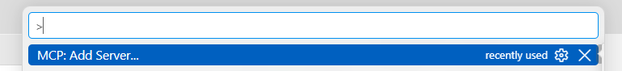
Select stdio
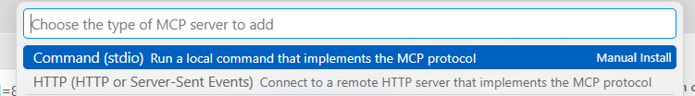
And enter the following command
npx -y @playwright/mcp@latest
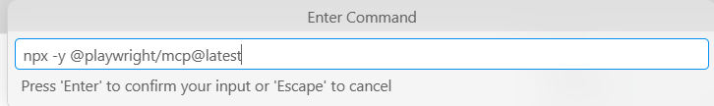
Give it a name
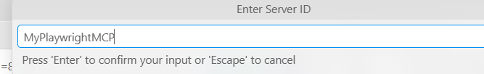
Set it to your current session
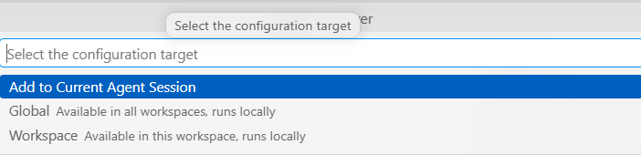

.Net 9.0.320
winget install --id Microsoft.DotNet.SDK.9 --version 9.0.320

VSCode
Download and install VSCode from https://code.visualstudio.com/download
Login to your github account


If you have PowerShell 7 installed (check previous steps) ensure you direct VSCode to use PowerShell 5
- Open VS Code.
- Press Ctrl + Shift + P (or Cmd + Shift + P on Mac) to open the Command Palette.
- Type and select PowerShell: Show Session Menu.
- Select Windows PowerShell (x64) (this is version 5.1

Lab 1 – Table and Columns
In this lab, you will use schema creation agents to automate the creation of a Dataverse table and its associated columns. The agents will load information from a provided data dictionary, interpret the schema definitions, and generate the required Dataverse artifacts. By the end of the exercise, you will have a fully configured table structure created through natural language instructions rather than manual configuration.

Prerequisites
- GitHub Copilot
- PowerShell 5 with XRM Modules

Steps
- Start your GitHub Copilot chat window (Ctrl + Alt + I) or (⌘ + Control + I)
- (❗important) Make sure to select the Create Dataverse Tables agent
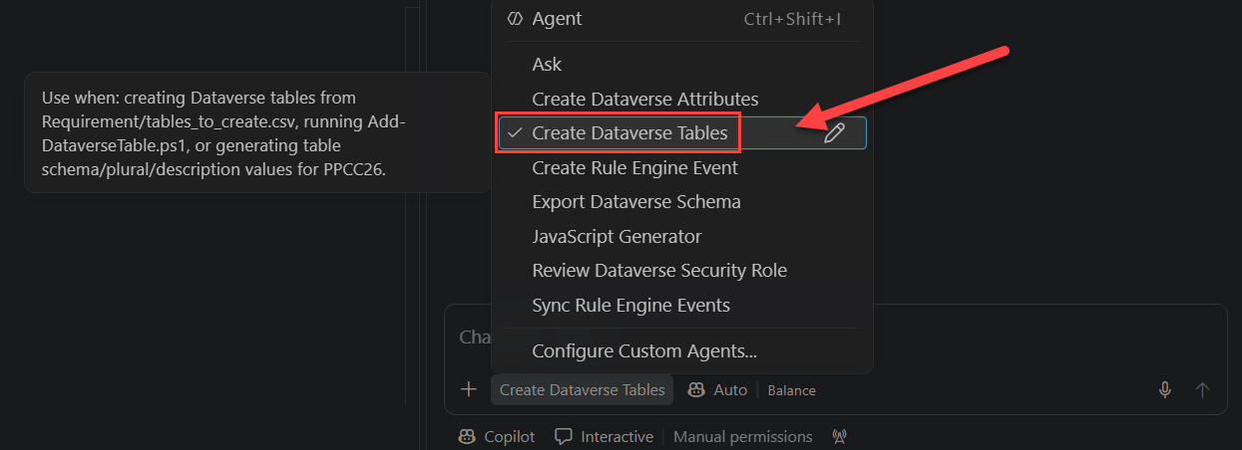
- Type the following prompt
Follow your prompt and create the new table Notification
as per the csv file. Don't deviate from the prompt's instructions.
- Once the command is completed, verify that the table has been created in Dataverse.
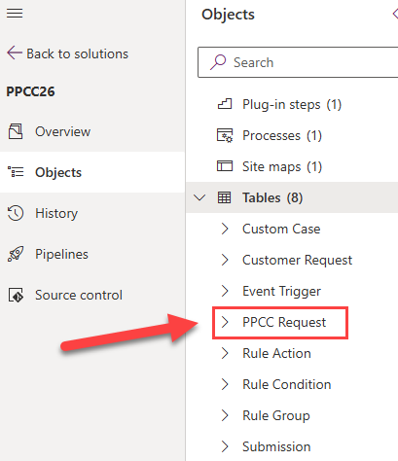
- (❗important) Switch to the Create Dataverse Attributes agent
- Type the following prompt
Follow your prompt and create the attributes for the ppcc_notification table as per the csv file. Don't deviate from the prompt's instructions
- Verify that the attributes have been created correctly.

Lab 2 - Update the forms / views / app using Skills
In this example, the requirement is to make additional fields visible and mandatory when the Type field is set to Other. The user provides the requirement in plain English, and the agent interprets the request, identifies the relevant fields and controls, retrieves the required metadata from the solution, and applies the appropriate utility. This removes the need for developers to manually analyse the schema, locate the relevant components, and implement the logic themselves, resulting in a faster and more efficient development experience.

Prerequisites
- GitHub Copilot
- PowerShell 5 with XRM Modules

Steps
- (❗important) Switch to the Form Editor agent
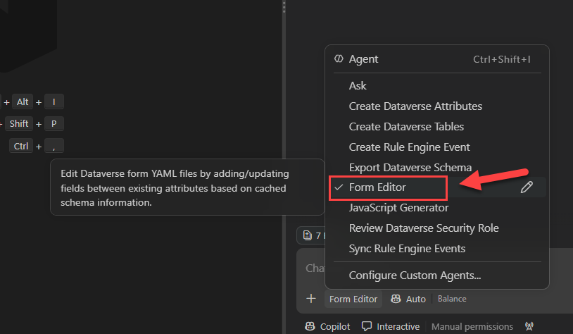
- Type the following prompt
Follow your instructions and update the Submission’s Portal form by adding the Description field between the "Fatality" and "Date of event" fields.
- Verify that the form was updated with the Description field in the middle.

Lab 3 – Solution deployment and Portal Changes
This lab builds on the previous exercise, where we used natural language instructions to implement form configuration. Now that our changes have been completed, the next step is to package and deploy them to another environment using the Solution Deployer Agent.
In this exercise, the agent will package the required components and execute the deployment process to the target environment. Rather than manually exporting, importing, and validating solutions, users can interact with the agent using plain English while it handles the underlying deployment tasks. This demonstrates how agentic automation can streamline application lifecycle management (ALM), reduce deployment effort, and help ensure changes are delivered consistently and reliably across environments.

Prerequisites
- GitHub Copilot
- PAC CLI
- Power Pages (optional)

Steps
- (❗important) Switch to the Solution Deployer agent
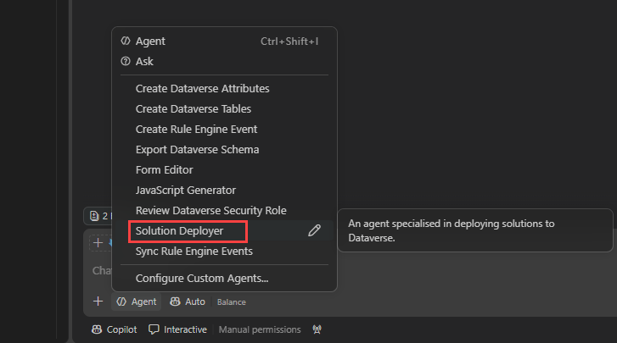
- Type the following prompt
Package and deploy your solution to the destination environment.
- Check that the solution has been deployed correctly in your environment.
- (Option) Check that your Power Pages Submission form has been updated.

Lab 4 – Low code Power Automate
In this exercise, we will update an existing low-code Cloud Flow and introduce new logic to ensure it complies with our business requirements. Because Cloud Flows are native low-code Power Platform components, we will use the out-of-the-box MCP capabilities to analyse the flow, identify the relevant actions and conditions, and apply the required changes through natural language instructions.
In this example, the Cloud Flow currently sets the Country field to New Zealand every time it runs. However, the requirement is to populate the field with New Zealand only when no country has been provided. The user will describe this requirement in plain English, and the agent will interpret the request, locate the relevant flow logic, and implement the necessary condition. This demonstrates how MCP-enabled agents can simplify low-code development by eliminating the need to manually inspect flow definitions, navigate complex workflows, or update expressions and conditions directly.

Prerequisites
- GitHub Copilot CLI
- Power-Platform Plugin (check lab [0] for set up instructions).
- Power Automate Skill (check lab [0] for set up instructions).

Steps
- Ensure you are logged in to your environment using az login:
az login --tenant 94edb735-a837-4d0d-80c3-4f9d2b11120c --allow-no-subscriptions
- Start the GitHub Copilot CLI by typing copilot in a terminal
- Ensure the Power-Automate skill is installed
- Type
power automat mcp server
- Then the prompt
Using the flowagent MCP server, update the Power Automate flow "Update Country to NZ" and add a condition to ensure the Country field is updated only when it is empty in the environment called dev. The flow ID is e08856df-0e91-4546-9e36-20d32c2824e5
- Check the “Update Country to NZ” has been updated correctly.

Lab 5 – Customization front-end using libraries
This section focuses on agents that can build and configure front-end JavaScript customisations. The goal is to establish a set of reusable libraries that address common business requirements, eliminating the need to repeatedly implement the same logic across different solutions. By promoting reusability and standardisation, these libraries accelerate development, improve consistency, and reduce ongoing maintenance effort.
These frameworks are designed to be AI-ready, meaning that the agents are aware of their capabilities and can leverage them when implementing a solution. Rather than generating custom code from scratch, the agent evaluates the requirement, determines whether an existing utility can satisfy the need, and automatically configures and wires the appropriate scripts into the application.
In this example, the requirement is to make additional fields visible and mandatory when the Type field is set to Other. The user provides the requirement in plain English, and the agent interprets the request, identifies the relevant fields and controls, retrieves the required metadata from the solution, and applies the appropriate utility. This removes the need for developers to manually analyse the schema, locate the relevant components, and implement the logic themselves, resulting in a faster and more efficient development experience.

Prerequisites
- GitHub Copilot

Steps
- (❗important) Switch to the JavaScript Generator agent
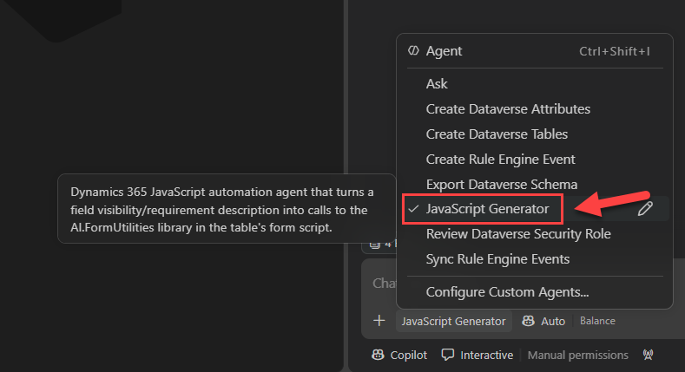
- Type the following prompt
Follow your prompt and add logic to the Custom Case form to make the Other field visible and mandatory when the Type field is set to Other. Reuse existing solution utilities where possible and avoid creating custom logic if an appropriate framework component already exists.
- Verify that your agent has update the ppcc_customcase.js web resource with the following details.

AI.FormUtilities.setupFieldVisibility(formContext, "ppcc_type", "ppcc_other", 100000004);
AI.FormUtilities.setupConditionalRequirement(formContext, "ppcc_type", "ppcc_other", 100000004);

- (optional) deploy the web resource with spkl ~\spkl\ deploy-webresources.bat
- (optional) test the changes in your custom case entity (might need to clear your cash and refresh your page).

Lab 6 – Customization back-end using AI-ready accelerator
This lab focuses on our custom-built AI-ready accelerator, which enables the execution of server-side business logic through data-driven instructions. Rather than developing and deploying plugins from scratch, the accelerator allows behaviour to be defined and configured dynamically, significantly reducing development effort, deployment complexity, and maintenance overhead.
During this exercise, you will use the accelerator to implement server-side logic by defining instructions and configuration data. This approach demonstrates how business rules and automation can be driven through metadata, enabling faster delivery, greater flexibility, and a more scalable development model compared to traditional plugin-based implementations.

Prerequisites
- GitHub Copilot
- PowerShell 5.1(optional)

Steps
- (❗important) Switch the Create Rule Engine Event agent
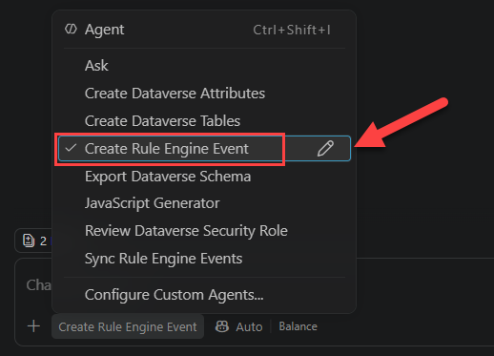
- Type the following prompt
Follow your prompt and create a new event that triggers on create of a custom case. If the type is set to fatality, then set the priority to high.
- Verify that your agent has created an event JSON file under Requirements/events
- (❗important ) Switch to the Sync Rule Engine Events agent
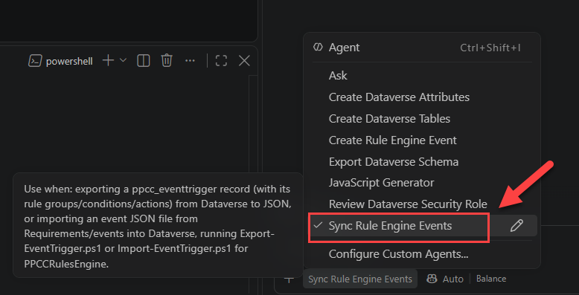
- (optional) Type the following prompt
Upload the customcase-fatality-priority.json
- (optional) Go to your Model Driven App and create a new Custom Case with a type of fatality and save it. Ensure that the priority has been updated to High.
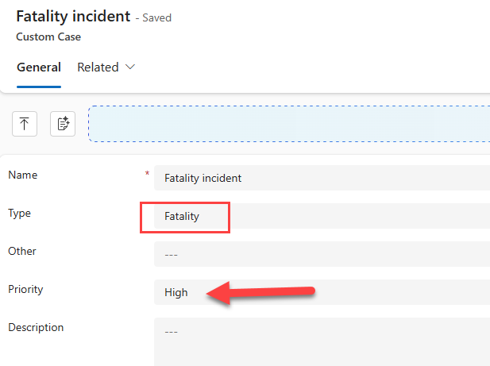

Lab 7 – Security Review
This lab focuses on a static analysis agent that reviews implemented security rules and validates them against a defined set of requirements. The purpose of this exercise is to demonstrate an agent's ability to analyze content, assess compliance with expected behavior, and identify gaps or inconsistencies.
During this lab, you will observe how an agent can evaluate security configurations, compare them to documented requirements, and provide feedback on areas that may require attention. While this example is centered on security, the same agentic pattern can be applied to a wide range of governance, compliance, and code quality assurance scenarios where implemented solutions need to be validated against established standards or business requirements.

Prerequisites
- GitHub Copilot

Steps
- (❗important) Switch to the Review Dataverse Security Role agent
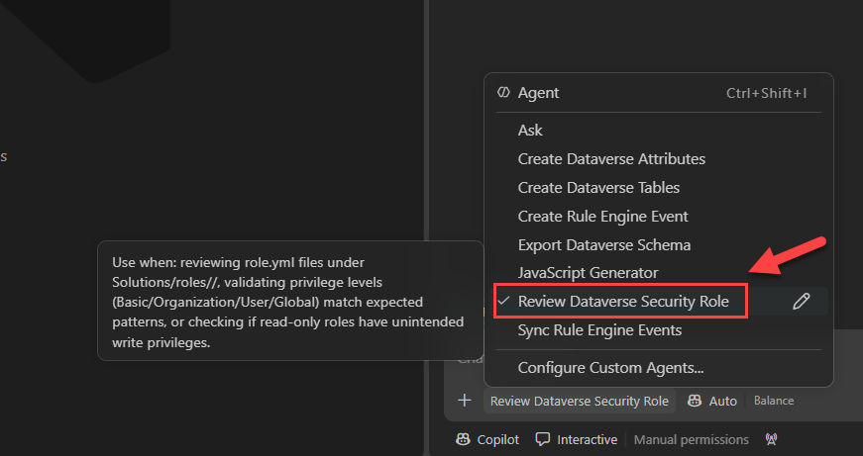

- Type the following prompt
Validate that the Rules Engine Read-Only security role grants read-only access and does not permit Create, Update, Delete, Append, Append To, Assign, or Share privileges. Summarize your findings in a clear, concise, and easy-to-read format.
- Review the prompt’s output.

Lab 8 – Testing using Playwright MCP
In this lab, we will use the Playwright MCP Server to connect to a Power Platform environment and interact with it through a web browser. The MCP server enables the agent to navigate the application, inspect pages, identify available functionality, and understand the structure of the environment without requiring users to manually explore it themselves.
In this exercise, the agent will connect to the environment, discover the available applications and components, and then create a new Custom Case record through the user interface. This demonstrates how MCP-enabled agents can perform end-to-end application interactions, combining environment discovery with automated execution of business tasks. By using natural language instructions, users can delegate repetitive activities to the agent, reducing manual effort and improving productivity.

Prerequisites
- Github Copilot
- Playwright MCP server (Check lab 0 for installation instructions)

Steps
- (❗important) Switch to default Agent mdoe
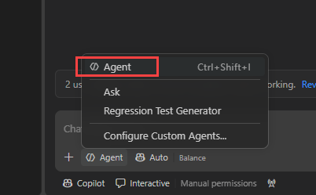
- Type the following prompt
Using the Playwright MCP server and VS Code's built-in browser navigate to the model driven app https://ppcc26dev.crm.dynamics.com/main.aspx?appid=e8bc1051-e9f9-4cae-9429-b25dec05bc9a using username Joe@ppcc2026workshop10.onmicrosoft.com and password PPCC26ppcc26 and create a new custom case give it a name ‘PPCC First Test’, set the type to fatality, save and close the record

Lab 9 – UI Regression Testing
- Inner loop
- Building reusable frameworks
- Unit testing and speed of testing

Prerequisites
- Github Copilot
- Visual Studio (optional)
- .NET 9.0 (optional)
If you get an error from playwright that the browser drivers are not installed, run the following command (PowerShell 7)
- pwsh bin/Debug/net9.0/playwright.ps1 install

Steps
- (❗important) Switch the Regression Test Generator agent
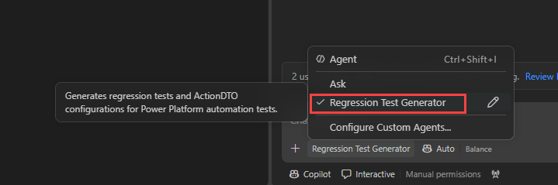
- Type the following prompt
Update UITest.json to create a custom case. Set the Name to PPCC26 Lab, the type to Fatality, and the priority to High.
- (option) To run the regression open the test explorer in Visual Studio and debug the test CreateCustomCase
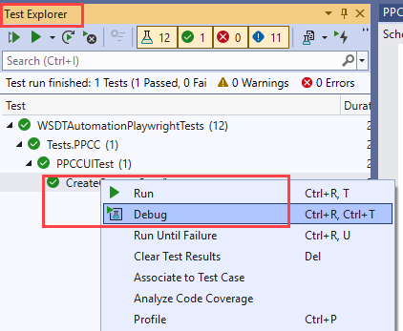
- If you are using VSCode run the following commands
dotnet build PPCC2026.csproj
dotnet run PPCC2026.csproj

